TaxPilot — Agentic Tax Filing Assistant

The problem
Build TaxPilot, a multi-agent assistant that turns a salaried taxpayer's documents into a reviewed Income Tax Return (ITR) draft for FY 2025-26 (AY 2026-27), with a human approving every decision that moves money.
Every July, millions of salaried Indians file returns from three documents that rarely agree: Form 16 from the employer, the Annual Information Statement (AIS) from the tax department, and their own investment proofs. Common failures:
- Income in AIS (FD interest, dividends) missing from the return, which triggers a mismatch notice.
- The wrong choice between the old and new tax regime, often costing ₹20,000 to ₹80,000.
- Deductions claimed without proof or above the section limit (80C, 80D, HRA).
Your team has 90 minutes to build an agent system that reads the documents, reconciles them, compares both regimes, asks the taxpayer to confirm the risky steps, and produces a filing-ready summary, fully traced in Langfuse.
Scope note: this is a training exercise. Tax rules are supplied as seed data in your MCP server (section 4); nothing is filed with the real portal.

What to build
A LangGraph supervisor runs four nodes in order, calls one MCP server, and pauses twice for the taxpayer.
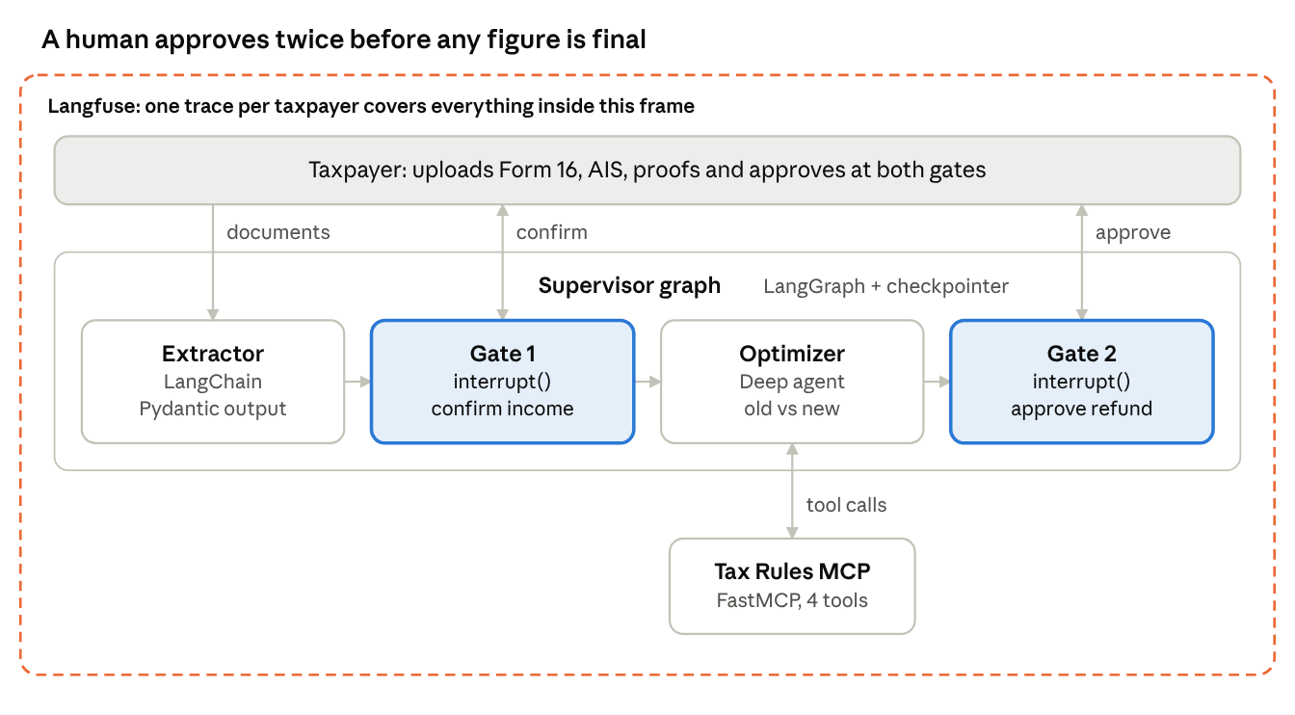
TaxPilot architecture · 4 graph nodes, 1 MCP server
The Extractor builds the profile and the AIS vs declaration diff; Gate 1 asks the taxpayer to confirm unexplained AIS income; the Optimizer (a deep agent) uses MCP tools to compare regimes; Gate 2 gets final approval before the summary is written.

Topic coverage and minimum requirements
Each of the seven topics maps to one component with a concrete acceptance check.
Topic | Component | Must do (acceptance check)
AI Agent | Every node below | Each agent has a clear role prompt, its own tools, and returns a typed result
LangChain | Document Extractor | Uses a chat model + with_structured_output(Pydantic) to turn raw Form 16 / AIS / proof text into TaxpayerProfile JSON
LangGraph | Supervisor graph | StateGraph with shared TaxState, conditional edges (mismatch found? proof missing?), and a checkpointer (MemorySaver)
Deep Agent | Regime Optimizer | Built with deepagents (create_deep_agent): writes a todo plan, uses its virtual files for working notes, spawns at least one sub-agent (e.g. HRA calculator) and outputs old vs new regime comparison
MCP | Tax Rules MCP server | FastMCP server exposing at least 4 tools (below); agents load them via langchain-mcp-adapters and never hard-code slabs or limits
Human in the loop | Approval gates | LangGraph interrupt() at 2 points: (1) confirm each mismatch is real income, (2) approve the final regime + refund/payable before "filing". Resume with Command(resume=...)
Langfuse tracing | Observability | Langfuse CallbackHandler on every run; one trace per taxpayer with session_id, tags per agent, the HITL decision logged as a score or event
MCP tools to expose (minimum):
- get_slab_rates(regime, fy) → slab list, standard deduction, 87A rebate limit
- get_deduction_limit(section) → cap for 80C, 80D, 80CCD(1B), 80TTA
- compute_hra_exemption(basic, hra_received, rent_paid, metro) → exempt amount + which of the 3 limits applied
- compute_tax(taxable_income, regime) → tax, rebate, 4% cess, total

Sample data and expected answer
Use the taxpayer below as the main test case. It contains one deliberate trap: FD interest of ₹38,000 appears in AIS but not in her declaration.
Taxpayer: Priya Sharma, salaried, Bengaluru (metro), age 31
{
"form16": {
"employer": "Acme Software Pvt Ltd",
"gross_salary": 1800000,
"basic": 720000,
"hra_received": 288000,
"professional_tax": 2400,
"tds_deducted": 195000
},
"ais": {
"salary": 1800000,
"savings_interest": 12000,
"fd_interest": 38000,
"tds_total": 195000
},
"declared_by_taxpayer": {
"rent_paid_annual": 300000,
"rent_receipts_available": true,
"sec_80c": {"epf": 86400, "elss": 63600},
"sec_80d_self": 25000,
"savings_interest": 12000
}
}
Seed rules for the MCP server (FY 2025-26):
Rule | Old regime | New regime
Slabs | 0–2.5L nil · 2.5–5L 5% · 5–10L 20% · >10L 30% | 0–4L nil · 4–8L 5% · 8–12L 10% · 12–16L 15% · 16–20L 20% · 20–24L 25% · >24L 30%
Standard deduction | ₹50,000 | ₹75,000
87A rebate | Taxable income ≤ ₹5L | Taxable income ≤ ₹12L
HRA, 80C, 80D, 80TTA, professional tax | Allowed | Not allowed
Limits | 80C ₹1.5L · 80D ₹25,000 (self, <60) · 80TTA ₹10,000 | —
Cess | 4% | 4%
Expected result (use to check your build):
Step | Old regime (₹) | New regime (₹)
HRA exempt (min of 2,88,000 / 2,28,000 / 3,60,000) | 2,28,000 | —
Gross total income (incl. ₹50,000 interest) | 15,69,600 | 17,75,000
Chapter VI-A deductions | 1,85,000 | —
Taxable income | 13,84,600 | 17,75,000
Tax + 4% cess | 2,36,995 | 1,61,200
TDS already paid | 1,95,000 | 1,95,000
Refund / (payable) | (41,995) | 33,800
Correct outcome: the system flags the FD interest at HITL gate 1, recommends the new regime (saves ₹75,795), and shows a ₹33,800 refund at HITL gate 2. A system that misses the FD interest will show the wrong figure and fail the expected-result check.
Two extra personas for stretch testing: a 62-year-old pensioner with ₹6L income (tests senior 80D limit and rebate), and a ₹11.5L earner (tests the new-regime 87A rebate bringing tax to zero).

Team split and 90-minute plan
.
Role | Owns | Topics practised
P1 — MCP engineer | Tax Rules MCP server + seed data + unit tests for compute_tax | MCP
P2 — Extraction engineer | Document Extractor chain, Pydantic TaxpayerProfile, AIS vs declaration diff | LangChain, AI Agent
P3 — Orchestrator | Supervisor StateGraph, routing, checkpointer, both interrupt() gates, CLI/Streamlit for approvals | LangGraph, Human in the loop
P4 — Deep agent engineer | Regime Optimizer with planning, sub-agent and virtual files | Deep Agent, MCP (consumer)
P5 — Observability and QA | Langfuse setup across all agents, HITL scores, end-to-end test against the expected table | Langfuse

Deliverables, demo and judging
Deliverables
- ☐ Repo with a README showing how to start the MCP server and the main graph
- ☐ filing_summary.json for Priya: income heads, deductions, both regimes, recommendation, refund, and the human decisions taken
- ☐ Langfuse link to one full trace showing every agent, MCP tool call and both approvals
Demo script (5 min)
- Load Priya's documents; show the extracted profile.
- Graph pauses at gate 1 on the ₹38,000 FD interest; presenter confirms it.
- Deep Agent shows its todo plan, its MCP tool calls and the regime table.
- Graph pauses at gate 2; presenter approves the new regime and the ₹33,800 refund.
- Open the Langfuse trace and walk through the spans.
Judging (100 points)
Criterion | Points
Correct numbers vs expected table | 25
All 7 topics present and working (as defined above) | 30
Human-in-the-loop: pauses, resumes and a rejection path (e.g. user says the FD is not theirs) | 15
Trace quality in Langfuse: one trace, named spans, session id, HITL score | 15
Code clarity and team integration | 15

